Aktobe, NIS NSM
Authors: Tynyshtyk Bektai, Kenges Sanzhar, Baltabayev Bek, 10th grade
Machine learning-based LDL cholesterol prediction
Applied Science Projects
Mentor: Tyrsynbayev Rayimbek
Aktobe, 2026

Abstract
This study aims to develop and validate a machine learning-based approach for accurate prediction of low-density lipoprotein cholesterol (LDL-C), a key biomarker in cardiovascular risk assessment. Traditional estimation methods such as the Friedewald, Martin, and Sampson formulas are widely used in clinical practice, but their accuracy decreases under certain conditions, particularly at high triglyceride levels.
The dataset used in this study consists of real clinical lipid profiles, including total cholesterol (TC), high-density lipoprotein cholesterol (HDL-C), triglycerides (TG), and directly measured LDL-C values as ground truth. Data preprocessing steps included cleaning, normalization, and transformation of triglyceride values to improve model performance.
Several machine learning models, including Random Forest and XGBoost, were trained and evaluated. Model performance was assessed using R², mean squared error (MSE), and Pearson correlation coefficient. The results were compared with traditional estimation formulas.
Among the tested models, XGBoost demonstrated the highest predictive accuracy, lowest error, and greatest stability across different triglyceride ranges. In contrast, traditional formulas showed decreased reliability at elevated triglyceride levels.
The findings suggest that machine learning methods, particularly XGBoost, provide a more accurate and robust alternative for LDL-C estimation. This approach has strong potential for use as a clinical decision-support tool, improving cardiovascular risk assessment and supporting more effective treatment strategies.

Introduction

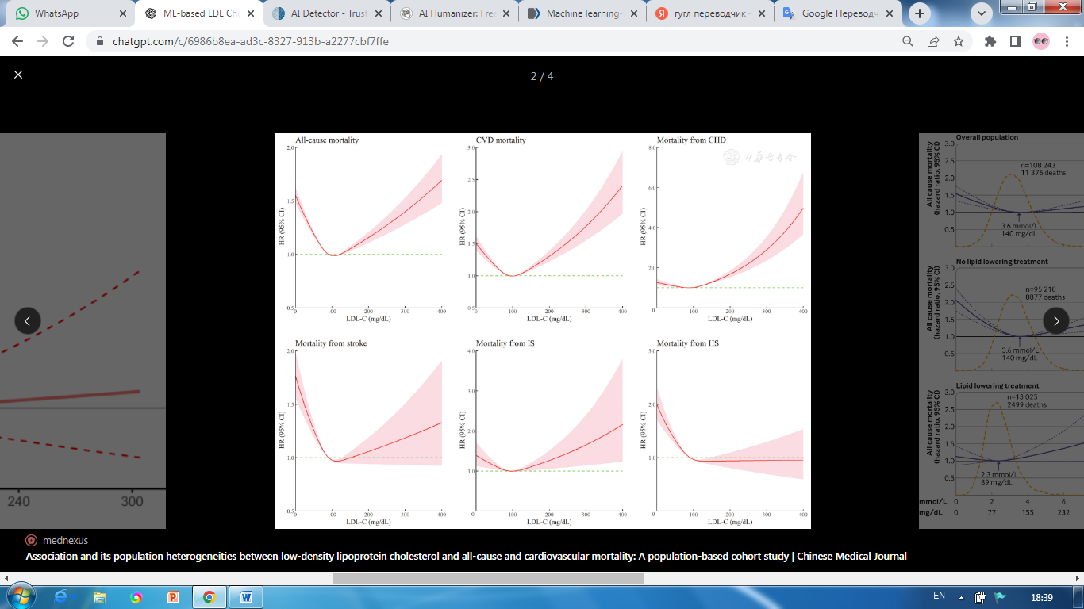

Figure 1. Hazard ratios for cardiovascular and all-cause mortality according to LDL-C levels. Adapted from Cardiovascular Innovations and Applications (2023).
Elevated LDL-C is widely recognized as one of the most significant modifiable risk factors for cardiovascular disease. Excess LDL particles accumulate within the arterial wall, contributing to the formation of atherosclerotic plaques that progressively narrow and stiffen blood vessels. Over time, this process can lead to life-threatening complications such as myocardial infarction, ischemic stroke, and peripheral artery disease. Because cardiovascular disease remains the leading cause of death worldwide, accurate identification and management of elevated LDL-C levels are essential components of preventive medicine.
According to cardiologist Eugene Braunwald, “The evidence that LDL cholesterol plays a causal role in atherosclerosis is strong and consistent across epidemiologic, genetic, and clinical trial data.” Cardiovascular diseases create a significant public health danger which leads to worldwide fatalities and permanent disabilities [1]. The biological and lifestyle-related risk factors that lead to cardiovascular disease demonstrate that dyslipidemia which involves high levels of low-density lipoprotein cholesterol LDL-C serves as a vital factor that begins and develops atherosclerotic cardiovascular disease ASCVD. The body experiences an inflammatory response when LDL-C particles penetrate the arterial intima because their oxidative modification creates plaque which narrows the arteries and causes myocardial infarction and stroke. According to international clinical guidelines medical professionals should measure LDL-C levels because it serves as the primary method to evaluate cardiovascular risk and initiate lipid-lowering treatment [1].
The need for high-risk LDL-C measurement accuracy has increased because early prevention methods and personalized treatment approaches and intensive lipid management techniques all require accurate LDL-C measurement. Physicians use LDL-C levels to make decisions about starting statin treatment adjusting doses and prescribing new lipid-lowering medications. The inaccurate estimation of LDL-C leads to treatment errors because it causes doctors to administer either too little or too much treatment which ultimately harms patient results. The healthcare sector depends on direct laboratory LDL-C testing for essential functions yet this testing method encounters two main challenges because it needs specialized facilities which standard clinical environments lack and medical facilities which lack essential resources. Direct assays require additional costs and longer testing times before obtaining results which creates barriers that limit their widespread use [2].
As a practical alternative, LDL-C is commonly estimated using calculation formulas derived from standard lipid panel measurements, including total cholesterol (TC), high-density lipoprotein cholesterol (HDL-C), and triglycerides (TG). The Friedewald equation has historically been the most widely used method due to its simplicity and ease of implementation. However, this equation assumes a fixed ratio between TG and very low-density lipoprotein cholesterol (VLDL-C), an assumption that does not hold across all metabolic conditions. Its accuracy declines substantially in patients with hypertriglyceridemia, diabetes mellitus, metabolic syndrome, or very low LDL-C concentrations. To address these limitations, alternative approaches such as the Martin and Sampson formulas have been proposed, introducing adjustable coefficients or more complex derivations. Although these methods demonstrate improved performance in certain scenarios, they remain constrained by predefined mathematical assumptions and may not generalize well across diverse populations and lipid profiles [3].
In this context, the application of machine learning (ML) techniques to LDL-C prediction has emerged as a promising and innovative direction. ML algorithms are capable of modeling complex, non-linear relationships within biomedical data without relying on rigid assumptions. By learning directly from large datasets of lipid profiles with known LDL-C measurements, ML-based models can capture subtle interactions among lipid parameters that traditional equations fail to account for. Recent studies have demonstrated that ML regression models can achieve superior accuracy and robustness compared to conventional estimation formulas, particularly in challenging clinical conditions characterized by high triglyceride levels [4].
The primary objective of this work is to reduce cardiovascular mortality with machine learning methods for predicting LDL-C levels using routinely available lipid profile data. Specifically, the study aims to evaluate whether ML-based regression models can provide more accurate and reliable LDL-C estimates than traditional calculation methods when compared against directly measured LDL-C values. In addition, the work seeks to assess model performance across different lipid ranges, thereby highlighting potential clinical advantages in real-world applications.
The research uses a retrospective dataset which contains lipid profile data that includes TC, HDL-C, TG and directly measured LDL-C values. The research methodology involves executing three steps which include data preprocessing, feature normalization and testing multiple machine learning regression algorithms. Cross-validation techniques are used for model training and validation to test model performance across different datasets. The ML models' predictive performance is assessed through standard statistical metrics which include coefficient of determination (R²) and mean squared error (MSE) and correlation coefficients, which are then compared to results obtained from traditional LDL-C estimation formulas. Through this approach, the study aims to demonstrate the practical value of machine learning as a decision-support tool in clinical lipid assessment and to contribute to the advancement of data-driven methods in cardiovascular risk management.
Research Section
1. Analytical Review of Known Results
1.1 Clinical Significance of LDL-C
Scientists identify low-density lipoprotein cholesterol (LDL-C) as the primary factor causing atherosclerotic cardiovascular disease. The research studies which include clinical and epidemiological research demonstrate that increasing LDL-C levels causes a direct increase in cardiovascular risk. The study results show that even small LDL-C level increases lead to a higher risk of coronary events and stroke and peripheral artery disease. The treatment options which require statin therapy and lifestyle changes use LDL-C as an important biomarker for their decision-making process.
Doctors use LDL-C testing results to create customized treatment plans which they monitor throughout the patient's treatment journey. The LDL-C value establishes complete cardiovascular danger through its association with HDL-C and triglycerides. Accurate LDL-C measurement proof essential for better patient results and for creating clinical practice guidelines based on research evidence.
The traditional formula-based methods create misclassification problems which occur especially with patients who have high triglyceride levels. The XGBoost model predicts LDL-C values with greater accuracy while matching clinical categories more effectively. The system enables accurate risk evaluation which enables physicians to make safe medical choices. The healthcare sector now shows actual benefits from using machine learning technology.
1.2 Direct Measurement of LDL-C
The two main direct LDL-C measurement methods used in laboratories are ultracentrifugation which acts as the gold standard and homogeneous enzymatic assays which medical facilities typically implement. The methods deliver precise results but their operational costs rise together with their laboratory requirements and the different performance levels exhibited by various testing companies. The process of ultracentrifugation demands both special apparatus and specialized knowledge plus a time commitment that makes it unavailable for standard medical use especially in facilities with limited resources. Even though homogeneous assays provide faster results their accuracy depends on the quality of reagents used and the standards set for calibration which results in unpredictable outcomes during patient monitoring.
Direct measurement methods need to be avoided for population screening because they create both financial and operational difficulties which prevent actual implementation. In many clinical settings, routine assessment of LDL-C may be deferred or limited to high-risk patients, potentially delaying intervention. The existing restrictions demonstrate the requirement for precise and affordable methods which can estimate LDL-C levels through both formula-based approaches and contemporary machine learning algorithms. The combination of direct measurement methods with predictive models enables quick and dependable LDL-C estimation which assists in clinical decision-making by enhancing risk evaluation without needing complicated laboratory evaluations.
1.3 Formula-Based LDL-C Estimation
The Friedewald, Martin, and Sampson formulas have long been standard methods for estimating LDL-C levels in clinical practice. By using total cholesterol, HDL-C, and triglycerides, they provide a cost-effective alternative to direct laboratory measurements and have significantly simplified lipid testing. However, their mathematical structure limits accuracy, especially given the variability of lipid profiles in modern patient populations.
A key limitation of these formulas is their reliance on fixed relationships derived from population averages. For example, the Friedewald equation assumes a constant TG/5 ratio to estimate VLDL-C, which does not reflect individual differences caused by genetics, diet, medications, or metabolic disorders. As a result, these static models often fail to capture real biological variability, leading to inaccurate LDL-C predictions.
These limitations become more pronounced under extreme conditions, particularly when triglyceride levels exceed 400 mg/dL, where the formulas lose reliability. Even improved versions like Martin and Sampson struggle in such cases. Since lipid metabolism involves complex nonlinear interactions, traditional linear formulas cannot fully represent these dynamics, highlighting the need for more advanced, data-driven approaches.
Friedewald Formula
The Friedewald equation has historically been the most common indirect method for LDL-C estimation:
​
The formula receives its foundational assumption through the estimation that very low-density lipoprotein cholesterol (VLDL-C) exists as a function of triglycerides which scientists express in mg/dL through a calculation using the value of 5. The equation provides computational efficiency and simple mathematical operations although its implementation depends on using a static relationship which exists between triglycerides and VLDL-C. The assumption fails to maintain its validity during most medical circumstances especially for patients who experience hypertriglyceridemia or diabetes or metabolic syndrome or display very low LDL-C levels. The formula becomes unreliable when triglyceride levels reach the threshold of 400 mg/dL [3].
Martin Formula
The Martin equation was developed to improve the limitations of the Friedewald method by introducing an adjustable factor instead of the fixed divisor of 5:
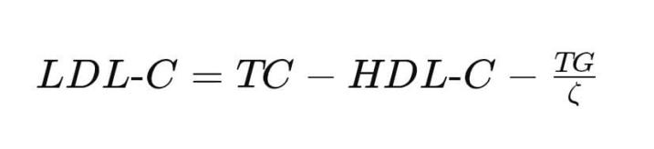
In this formula, ζ is an adjustable coefficient determined from a lookup table based on triglyceride and non-HDL cholesterol levels. This adaptive approach provides better estimation across a broader range of triglyceride concentrations. However, despite its improved flexibility, the Martin formula still relies on predefined stratification tables and assumes structured relationships between lipid variables. It does not fully capture complex nonlinear interactions between lipid components, which may limit its performance in highly heterogeneous patient populations.
Sampson Formula
The Sampson equation was proposed as a more advanced regression-based correction, particularly for patients with elevated triglyceride levels. One commonly presented version of the equation is:
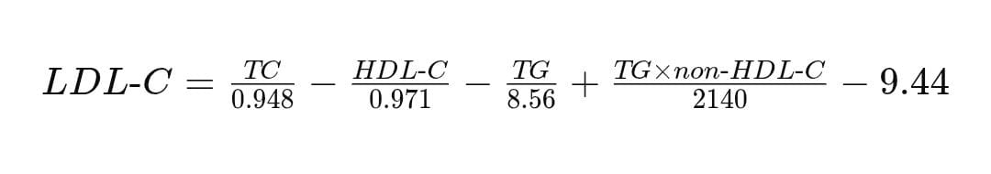
This formula incorporates nonlinear correction terms and interaction components to improve accuracy, especially when triglyceride levels are moderately high. Compared to Friedewald and Martin equations, it performs better in hypertriglyceridemic conditions. However, despite its complexity, the Sampson formula remains a fixed mathematical model derived from regression assumptions. It cannot dynamically adapt to new data distributions or unseen metabolic patterns, which restricts its generalizability across diverse populations.
Although the Friedewald, Martin, and Sampson equations represent progressive improvements in LDL-C estimation, they share a fundamental limitation: they rely on predefined mathematical assumptions and fixed relationships between lipid parameters. As a result, they cannot fully capture the biological variability observed in real patients, especially under conditions such as elevated triglyceride levels.
In contrast, machine learning models can learn complex nonlinear relationships directly from clinical data without relying on rigid equations. In this study, several models, including Random Forest and XGBoost, were evaluated.
Among them, XGBoost demonstrated superior predictive accuracy, stability, and robustness across different triglyceride ranges. Its gradient boosting mechanism allows it to iteratively reduce prediction errors and capture hidden patterns in the data.
Therefore, the transition from formula-based estimation to machine learning represents a significant methodological advancement, enabling more accurate, adaptable, and clinically reliable LDL-C prediction.
1.4 Machine Learning Approaches in Lipid Prediction
Recent studies demonstrate that machine learning models significantly outperform traditional equations in LDL-C prediction. ML algorithms show their strength when they handle non-linear relationships and complex feature interactions without needing to make specific assumptions. The different patient groups and triglyceride levels show that ensemble methods and neural networks provide strong performance results [4].
2. Description of the Methods for Solving Tasks
2.1 Dataset
The dataset consists of lipid panel records containing TC, HDL-C, TG, and directly measured LDL-C values. Feature engineering includes normalization, log-transformation of triglycerides, and stratification by TG levels to assess model robustness.

Feature | Unit | Description
TC | mg/dL | Total cholesterol
HDL-C | mg/dL | High-density lipoprotein cholesterol
TG | mg/dL | Triglycerides
LDL-C | mg/dL | Directly measured reference value
Age | number | Age of patient
Table 1. Lipid profile dataset structure
Table 1 summarizes the structure of the lipid profile dataset used in this study. The dataset includes total cholesterol (TC), high-density lipoprotein cholesterol (HDL-C), triglycerides (TG), and directly measured LDL-C, which serves as the ground truth for model evaluation. All variables are expressed in standard clinical units (mg/dL).
The data were obtained from Yanbian University Hospital and collected between 2020 and 2023, ensuring real-world clinical relevance and reliability.
To improve data quality and model performance, preprocessing steps included data cleaning, normalization of continuous variables, and log transformation of triglycerides to address skewness and enhance the modeling of nonlinear relationships.
In addition, the dataset was stratified by triglyceride levels to evaluate performance under different metabolic conditions, particularly in hypertriglyceridemic cases where traditional LDL-C estimation formulas are known to be less reliable.
This data preparation strategy enables machine learning models to capture complex relationships between lipid parameters and ensures stable, accurate, and clinically relevant LDL-C predictions across diverse patient populations.
2.2 XGBoost Model
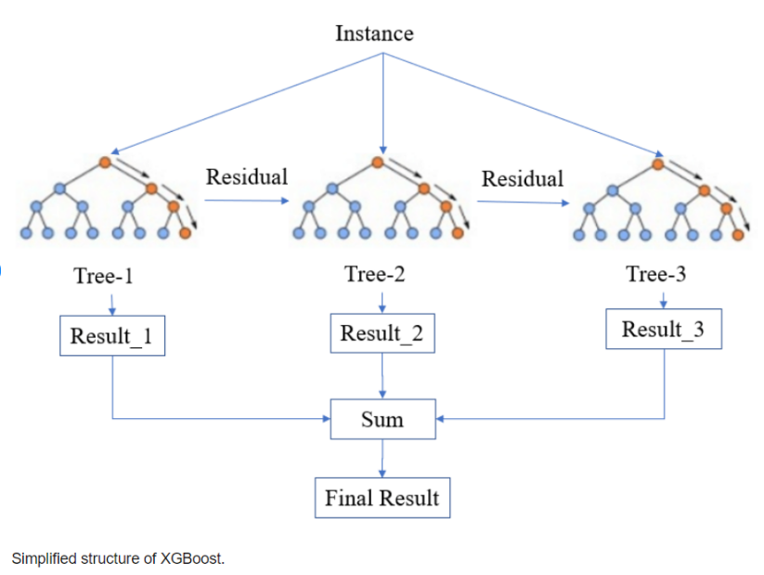
Figure 2. Simplified structure of XGBoost
The study uses XGBoost regression, which is based on decision tree ensemble machine learning methods, to predict low-density lipoprotein cholesterol (LDL-C) levels. The algorithm predicts biomedical outcomes because it can model complex non-linear patterns while maintaining accuracy across various data types. The XGBoost model creates its main model structure through the development of multiple decision trees which it uses during its training process. XGBoost establishes its tree structure through sequential development of trees which follow a gradient boosting method that trains each tree to fix the prediction mistakes made by all previously constructed trees. The model training process uses an iterative approach which leads to better performance because it decreases prediction errors that remain after completing the work.
During training, the algorithm optimizes an objective function that combines prediction loss with regularization terms controlling model complexity. The optimization process prevents overfitting by protecting model performance but it enables the model to capture important data connections. The algorithm tests different features at every decision tree split point and it chooses the feature which provides the highest objective function improvement. The LDL-C prediction input features consist of total cholesterol (TC), high-density lipoprotein cholesterol (HDL-C), and triglycerides (TG) measurements. The model establishes its knowledge base through multiple splits that utilize these features because the model needs to recognize relationships between lipid variables.
Each decision tree generates a partial LDL-C prediction based on the relationships it learns from lipid parameters in the training data. The XGBoost regression model produces its final output by summing the contributions of all trees in the ensemble. The model uses an additive modeling method which enables exact prediction improvement through tree additions. The aggregation of multiple trees improves prediction stability, reduces the influence of noise and outliers, and provides stronger predictive performance compared with single-tree models.
XGBoost regression offers a major benefit because it can model complicated relationships between triglycerides and other lipid components without requiring predefined mathematical formulas. This concept holds special significance in lipid metabolism research because biochemical markers often demonstrate non-linear relationships that vary across different metabolic states. The model provides feature importance scores which show the impact of TC, HDL-C, and TG on LDL-C prediction.

The primary issue that people raise against machine learning systems relates to their operation as "black box" systems which deliver predictions without providing understandable details. The XGBoost regression offer essential tools for understanding their operation through their capability to show which features matter most.
The feature importance metric calculates the effect that each input variable has on the ability of the model to make accurate predictions. The analysis establishes which lipid parameters have the strongest impact on LDL-C prediction results according to research processes which scientists employ. The total cholesterol and triglyceride measurements deliver stronger predictive power than all other measurements do, also factors such as age have very low effect on prediction.
Feature importance displays create evidence that the model generates its predictions from valid biological connections instead of random statistical connections. The algorithm gains higher trustworthiness through its transparent operations which make it suitable for use in clinical decision support systems.
Cross-validation helps find the ideal combination of prediction accuracy and model generalization through the optimization process which adjusts the hyperparameters for tree count and tree depth and minimum sample requirements for both splits and leaves. The research team chose XGBoost regression as their only machine learning technique for LDL-C prediction because it offers clear explainability and dependable results that previous research studies have established.

2.3 Random Forest Regression Model
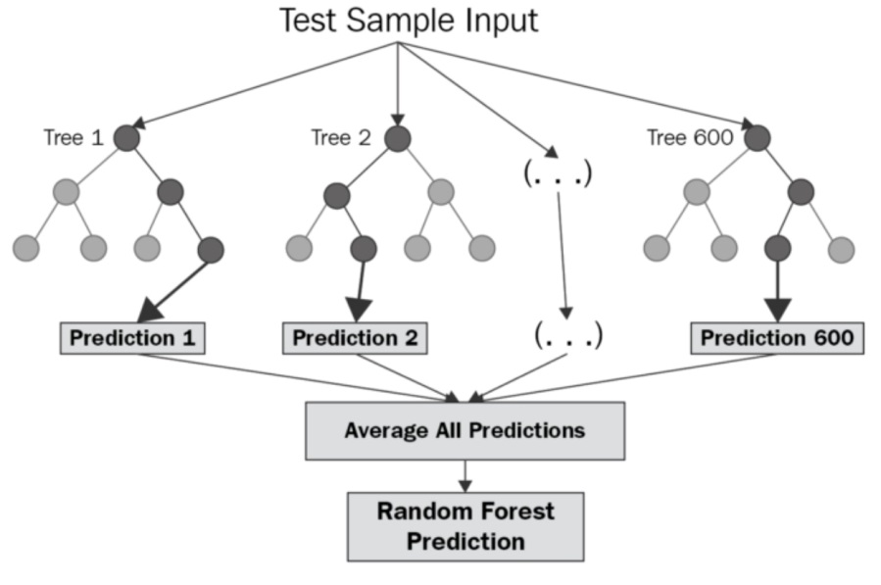
Figure 3. Random Forest Regression model workflow
The study uses Random Forest regression which is based on decision tree ensemble machine learning methods to predict low-density lipoprotein cholesterol (LDL-C) levels. The Random Forest algorithm predicts biomedical outcomes because it can model complex non-linear patterns while maintaining accuracy across various data types. The Random Forest algorithm creates multiple decision trees which function as its core operational structure during training. The system trains each tree on a randomly chosen portion of the original dataset through a method called bootstrap aggregation (bagging). The process involves drawing samples from training data with replacement to create trees which leads to two outcomes: increased tree diversity and decreased model variance.
The decision tree requires a random selection of input features at each node instead of assessing all available input features. The LDL-C prediction input features consist of total cholesterol (TC), high-density lipoprotein cholesterol (HDL-C), and triglycerides (TG) measurements. The algorithm achieves tree separation through its feature selection method which chooses attributes at every split point to establish independent tree structures that create better ensemble predictions.
The decision tree generates an independent LDL-C prediction which uses learned lipid parameter relationships to produce its results. The Random Forest regression model produces its final output through the process of averaging all tree predictions which exist within the model. The aggregation method provides multiple benefits which include prediction stabilization together with decreased noise and outlier effects while offering better protection than single-tree models.
Random Forest regression offers a major benefit because it can model the complicated relationships between triglycerides and other lipid elements without needing mathematical models that experts have already established. This concept holds special significance for lipid metabolism because biochemical markers show non-linear relationships which shift according to different metabolic states. The Random Forest models show feature importance results which enable determination of how much TC and HDL-C and TG factors contribute to LDL-C prediction.
Cross-validation helps find the ideal combination of prediction accuracy and model generalization through the optimization process which adjusts the hyperparameters for tree count and tree depth and minimum sample requirements for both splits and leaves. The research team chose Random Forest regression as their only machine learning technique for LDL-C prediction because it offers clear explainability and dependable results that previous research studies have established.

2.4 Methods and Technical Details of Model Training
The machine learning models, including Random Forest and XGBoost, were used to predict LDL-C levels through a structured pipeline involving data preprocessing, model training, hyperparameter optimization, and validation on both internal and external datasets. The internal dataset, containing clinical lipid profiles, was used for model development and initial evaluation, while the external dataset served as an independent benchmark to assess real-world generalization.
The workflow begins with data preprocessing, where column names are standardized, non-numeric values are removed, and missing data is handled to ensure consistency and reliability. The dataset is then split into training and testing subsets prior to model training, preventing data leakage. All preprocessing steps are applied within a pipeline during training, ensuring that transformations are learned only from the training data.
Both models are based on decision tree ensembles. Random Forest builds multiple independent trees and aggregates their predictions, while XGBoost uses gradient boosting, where each new tree iteratively corrects the errors of previous ones. To ensure robust performance, 5-fold cross-validation is used, allowing the models to be evaluated across multiple data splits. Hyperparameters such as the number of estimators, maximum tree depth, and learning rate are optimized using GridSearchCV, which systematically searches for the best configuration based on the R² metric.
Model performance is evaluated on the test dataset using multiple metrics, including R², Mean Squared Error (MSE), and Pearson Correlation Coefficient (PCC). These metrics provide a comprehensive assessment of prediction accuracy, error magnitude, and correlation with actual LDL-C values. The results demonstrate that both models effectively capture the relationship between lipid features and LDL-C levels, with XGBoost showing the best overall performance.
Finally, the models are validated on an external dataset consisting of previously unseen patient data. This step is critical for assessing real-world applicability and generalization. The results show that machine learning models provide more stable and accurate predictions compared to traditional LDL-C estimation formulas, particularly under varying clinical conditions.

2.5 Algorithm and Code Implementation
The LDL-C prediction system is implemented using a structured machine learning pipeline that includes data preprocessing, model training, hyperparameter optimization, evaluation, and external validation. To ensure transparency and reproducibility, key parts of the implementation are demonstrated using real code snippets.
Data Preprocessing
The dataset is cleaned and prepared by standardizing column names, converting values to numeric format, and removing missing or inconsistent entries. Feature variables (TC, TG, HDL-C, Age) are separated from the target variable (LDL-C).
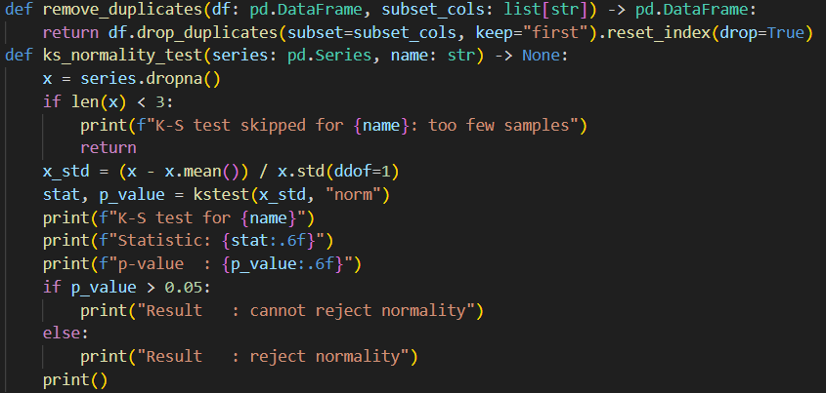

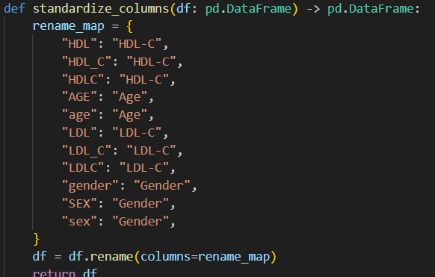
Model Training and Hyperparameter Optimization
The models are trained using GridSearchCV with 5-fold cross-validation. This process evaluates multiple hyperparameter combinations and selects the best-performing model based on the R² metric.

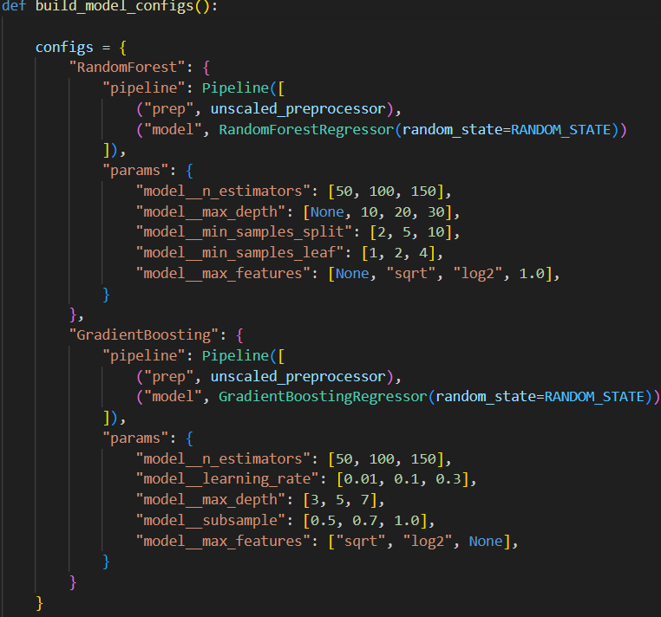
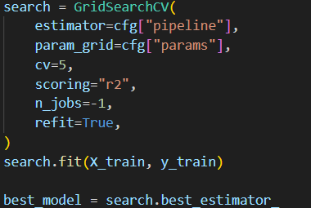

Selection of the Best Model
After training, the best model is automatically selected using the optimal hyperparameters identified during cross-validation

Prediction and Evaluation
The trained model is applied to the test dataset to generate predictions. Model performance is evaluated using multiple metrics, including R², Mean Squared Error (MSE), Mean Absolute Error (MAE), and Pearson Correlation Coefficient (PCC).
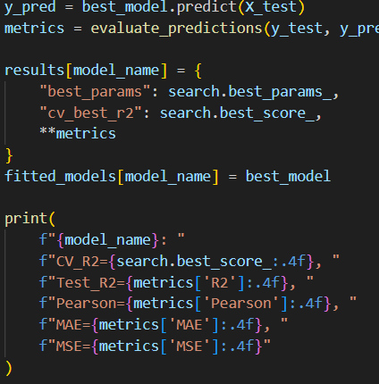
Visualization of Results
Model predictions are compared with actual LDL-C values using visualization techniques such as actual vs predicted plots and residual plots. These graphs provide insight into model accuracy and error distribution.

External Validation
To assess real-world performance, the trained models are applied to an external dataset consisting of previously unseen patient data. This step evaluates the generalization ability of the model.

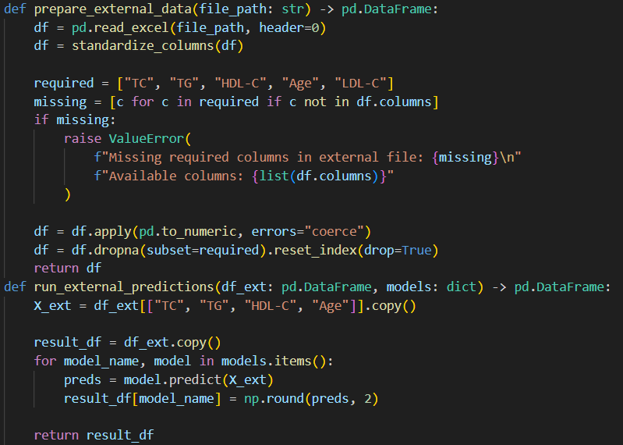

Comparison with Traditional Methods
Finally, the machine learning predictions are compared with traditional LDL-C estimation formulas such as Friedewald, Martin, and Sampson. This comparison highlights the advantages of machine learning models in terms of accuracy and stability.

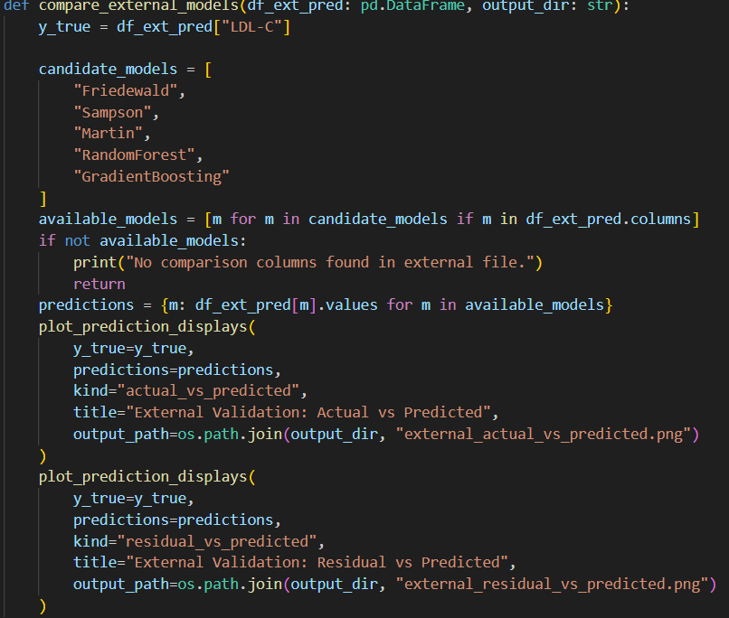

2.6 Practical Implementation

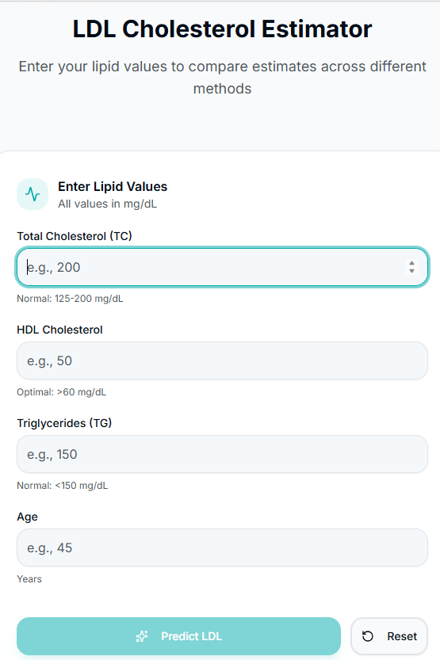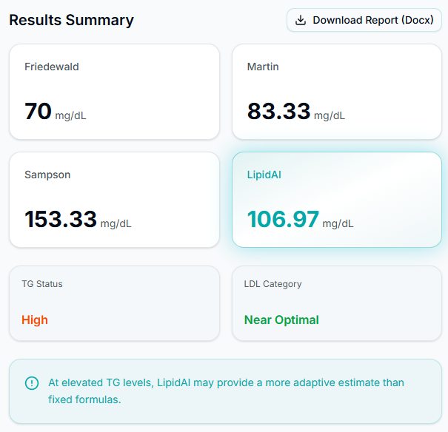

The LipidAI website (lipidai.vercel.app) provides an interactive tool for predicting LDL-C levels using standard lipid panel measurements. Users input three commonly available clinical values - total cholesterol (TC), HDL-C, and triglycerides (TG) - obtained from routine blood tests. Based on these inputs, the system generates LDL-C predictions using a trained XGBoost model, without requiring additional laboratory procedures.
In addition to machine learning predictions, the platform also calculates LDL-C values using traditional formulas such as Friedewald, Martin, and Sampson. This allows users to directly compare different estimation methods and better understand how prediction accuracy varies under different lipid conditions, especially when triglyceride levels are elevated.
The system is powered by a FastAPI-based backend that processes user input and generates predictions efficiently. This architecture ensures fast response times and scalable performance, while the separation between the user interface and the model layer enables stable and reliable operation even under multiple requests.
A key advantage of LipidAI is its ability to make advanced machine learning models accessible through a simple and user-friendly web interface. Users, including clinicians, researchers, and students, can obtain data-driven LDL-C predictions without requiring knowledge of machine learning or programming.
The platform also emphasizes transparency and responsible use. It is clearly presented as an educational and decision-support tool, not a substitute for professional medical advice. At the same time, it demonstrates how machine learning can enhance traditional LDL-C estimation and improve cardiovascular risk assessment.
Additionally, the system provides visual comparison through interactive graphs and allows users to export results as structured reports, supporting further analysis and documentation. Overall, LipidAI serves as a modern, practical, and accessible tool that combines machine learning and classical methods to improve LDL-C estimation and support informed decision-making.
2.7. Advantages of the LipidAI Machine Learning Approach
The LipidAI platform provides a significant advancement over traditional LDL-C estimation methods by integrating machine learning predictions with classical formulas and visual comparison tools. The system delivers results through XGBoost which operates distinct from Friedewald and Martin and Sampson formulas so users can see how their predictions differ. This approach enables better comprehension of estimation method performance because it evaluates different lipid conditions through testing which includes elevated triglyceride levels.
The system provides its main benefit because it can create models which represent intricate nonlinear associations among different lipid parameters. The XGBoost algorithm learns directly from real clinical data which enables it to capture total cholesterol and HDL-C and triglyceride interactions that traditional formulas cannot represent. The system produces better accurate and reliable LDL-C predictions which perform especially well in situations where traditional methods create systematic errors.
The platform demonstrates better stability through testing various lipid profiles. The machine learning model creates constant results because traditional formulas lose precision when triglyceride levels exceed 400 mg/dL. The clinical risk assessment process depends on this stability because it decreases misclassification risks while enabling better treatment choices.
Another important benefit is accessibility and interpretability. Users of the web-based interface can enter their lipid values to obtain both predicted LDL-C levels and complete traditional formula comparisons with an interactive graph. The system provides numerical results together with visual displays, which benefit researchers, clinicians, and educational institutions.
LipidAI proves itself as an accurate and transparent system which maintains user-friendly design. The system uses machine learning to improve cardiovascular risk assessment, while it serves as a modern substitute for traditional LDL-C estimation methods.
2.8. Difference between Formulas and LipidAI
Limitations of Traditional Formulas | LipidAI Solution
Fixed mathematical coefficients | Data-driven learning from large datasets
Inaccurate when TG > 400 mg/dL | Maintains stability across wider lipid ranges
Cannot capture nonlinear relationships | XGBoost detects complex nonlinear patterns
Based on simplified assumptions | Model adapts to real biological variability
Static equations | Continuously improvable with new data
Table 2. Limitations of Traditional Formulas and LipidAI Solutions.
The comparison between traditional formula-based LDL-C estimation methods and LipidAI machine learning methods shows their fundamental differences through Table 2. Conventional formulas rely on fixed mathematical relationships derived from population averages and simplified physiological assumptions. The equations offer a fast method to estimate LDL-C levels, but their unchanging design restricts them from showing different results based on each patient. The fixed equations of the study fail to represent biological systems, because lipid metabolism requires multiple genetic, metabolic, lifestyle and medication-related factors to achieve its full complexity. The presence of unusual lipid profiles particularly affects their precision during hypertriglyceridemia and metabolic disorders.
The LipidAI model uses a machine learning framework which operates through data-driven methods to overcome these challenges. The XGBoost algorithm detects patterns by studying a complete dataset which contains patient lipid measurements instead of using fixed coefficients. The model identifies how lipid parameters interact with each other while it learns to function properly under various biological systems. The model achieves consistent predictive results when dealing with different lipid levels and it provides users with access through a web-based system. The LipidAI system provides a current solution that integrates flexible operations with accurate predictions and user-friendly functions to replace traditional LDL-C estimation methods.

3. Results and Discussion
3.1 Quantitative Results

Method | TG category (mg/dL) | R ² | MSE | PCC
Friedewald Formula | >0 and <100 | 0.93 | 96.83 | 0.97
 | ≥100 and <150 | 0.91 | 135.65 | 0.96
 | ≥150 and <200 | 0.85 | 213.94 | 0.94
 | ≥200 and <300 | 0.73 | 380.76 | 0.90
 | ≥300 and <400 | 0.52 | 711.97 | 0.82
 | ≥400 | −0.14 | 1,498.04 | 0.68
Sampson Formula | >0 and <100 | 0.93 | 101.82 | 0.97
 | ≥100 and <150 | 0.91 | 129.90 | 0.96
 | ≥150 and <200 | 0.88 | 178.68 | 0.94
 | ≥200 and <300* | 0.79 | 305.62 | 0.90
 | ≥300 and <400 | 0.61 | 578.33 | 0.82
 | ≥400 | 0.15 | 1,118.14 | 0.67
Martin Formula | >0 and <100 | 0.93 | 94.32 | 0.97
 | ≥100 and <150* | 0.91 | 124.00 | 0.96
 | ≥150 and <200* | 0.88 | 172.72 | 0.94
 | ≥200 and <300 | 0.77 | 331.29 | 0.90
 | ≥300 and <400 | 0.46 | 805.70 | 0.82
 | ≥400 | −0.77 | 2,320.61 | 0.64
Random Forest Regression Model | >0 and <100 | 0.93 | 94.95 | 0.97
 | ≥100 and <150 | 0.90 | 142.89 | 0.96
 | ≥150 and <200 | 0.87 | 185.36 | 0.94
 | ≥200 and <300 | 0.78 | 321.81 | 0.91
 | ≥300 and <400 | 0.63 | 554.82 | 0.86
 | ≥400 | 0.43 | 740.54 | 0.78
XGBoost Model | >0 and <100 | 0.94 | 89.25 | 0.97
 | ≥100 and <150 | 0.91 | 132.44 | 0.96
 | ≥150 and <200 | 0.88 | 174.44 | 0.95
 | ≥200 and <300 | 0.78 | 313.78 | 0.91
 | ≥300 and <400 | 0.63 | 552.45 | 0.86
 | ≥400 | 0.44 | 737.84 | 0.78

Начало формы
Конец формы
Table 3. Values of R² and MSE, PCC for different models at various TG intervals.
The internal validation results, presented in , evaluate LDL-C estimation methods across different triglyceride (TG) ranges using key performance metrics, including R², MSE, MAE, RMSE, Pearson correlation coefficient (PCC), and bias. These metrics provide a comprehensive assessment of model accuracy, error magnitude, and prediction consistency under varying lipid conditions.
R² (coefficient of determination) measures how well predicted LDL-C values explain the variability of actual values, with values closer to 1 indicating better performance. MSE (Mean Squared Error) and RMSE (Root Mean Squared Error) quantify prediction errors, giving higher weight to larger deviations, while MAE (Mean Absolute Error) represents the average absolute prediction error. Pearson correlation coefficient (PCC) evaluates how strongly predicted values follow real LDL-C values, and bias reflects systematic over- or underestimation, which is critical in clinical applications.
The results demonstrate that traditional formulas, including Friedewald, Martin, and Sampson, show decreasing accuracy as triglyceride levels increase. At TG levels above 400 mg/dL, these methods exhibit significantly lower R² values and higher error metrics, indicating reduced reliability in high-risk clinical conditions.
In contrast, both machine learning models - Random Forest and XGBoost - maintain more stable and accurate performance across all TG ranges. They consistently achieve higher R² values and lower prediction errors compared to traditional formulas, demonstrating their ability to model complex nonlinear relationships between lipid parameters.
Between the two machine learning approaches, XGBoost shows the best overall performance, with slightly higher accuracy and more consistent results across different triglyceride levels. This indicates its superior capability for LDL-C prediction while maintaining robustness under challenging conditions.
Overall, the results confirm that machine learning models provide more accurate and clinically reliable LDL-C predictions than traditional formulas, with XGBoost emerging as the most effective approach.
3.2 Visual Analysis
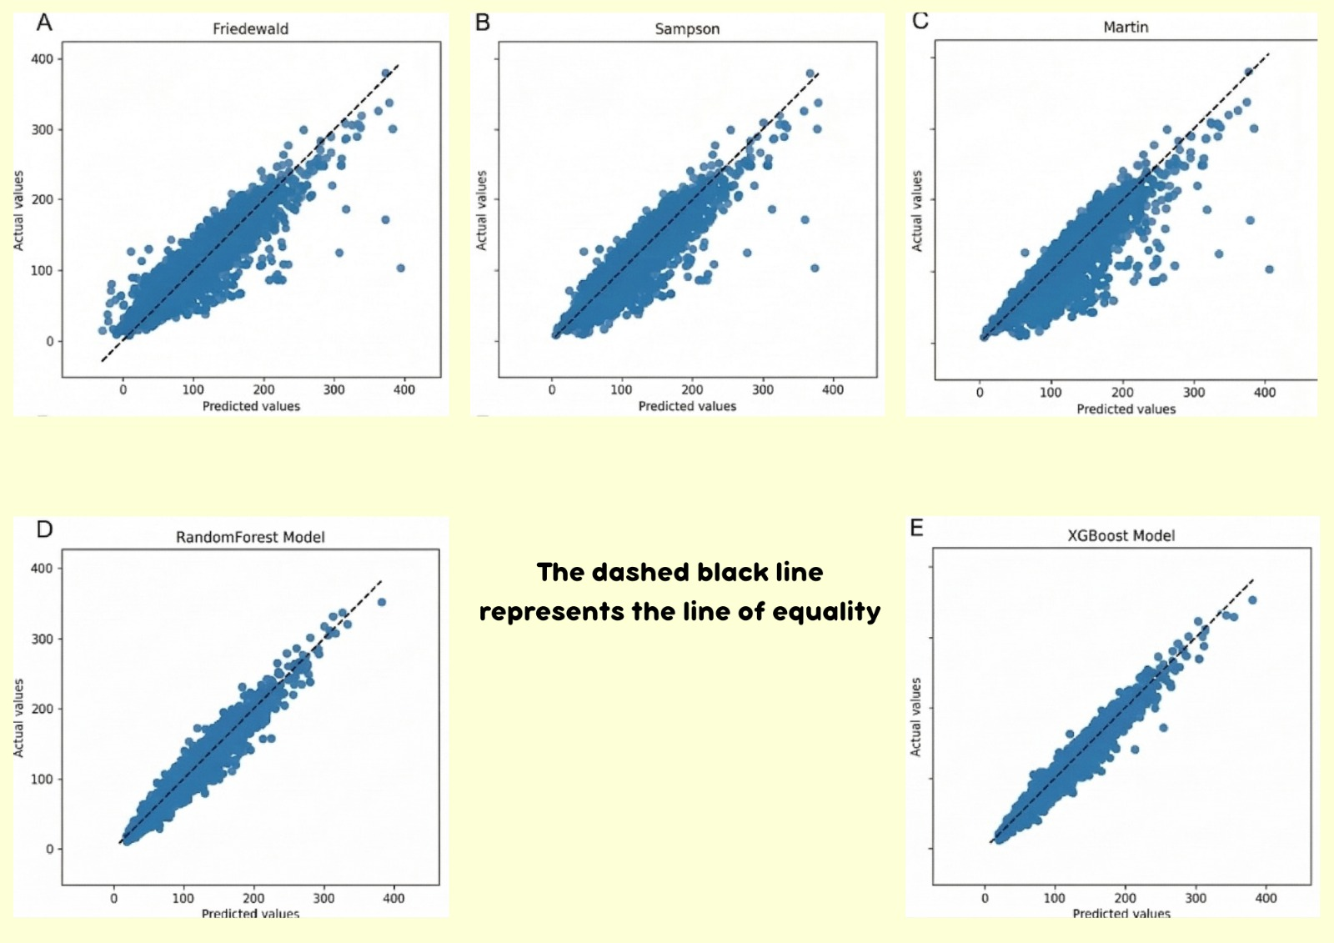

Figure 5. Comparison of predicted and measured LDL-C values using the XGBoost model. The dashed line represents the ideal agreement line (y = x).
Scatter plots comparing predicted LDL-C values with actual laboratory measurements provide a visual assessment of model performance. In these plots, true LDL-C values are shown on the x-axis, while predicted values from each method are shown on the y-axis. The reference line y=xy = xy=x represents perfect agreement, and predictions that lie closer to this line indicate higher accuracy. Deviations from this line reflect prediction errors, while systematic shifts above or below it indicate consistent overestimation or underestimation.
The results show that traditional formulas, including Friedewald, Martin, and Sampson, exhibit increasing dispersion as triglyceride and LDL-C levels rise. This spread indicates reduced accuracy and the presence of systematic errors, particularly in higher lipid ranges.
In contrast, machine learning models, including Random Forest and XGBoost, demonstrate improved alignment with the identity line across the full range of values. Their predictions are more tightly clustered, indicating better calibration and reduced error. This reflects their ability to model complex nonlinear relationships between lipid parameters, which traditional formulas cannot capture.
Among the machine learning approaches, XGBoost shows the best overall agreement with actual LDL-C values. Its predictions remain consistently close to the identity line, with fewer deviations and more stable behavior across different lipid ranges. This indicates superior predictive accuracy and robustness compared to both traditional formulas and Random Forest.
Overall, the visual analysis confirms that machine learning models provide more accurate and reliable LDL-C predictions, with XGBoost achieving the highest level of agreement with clinical measurements.
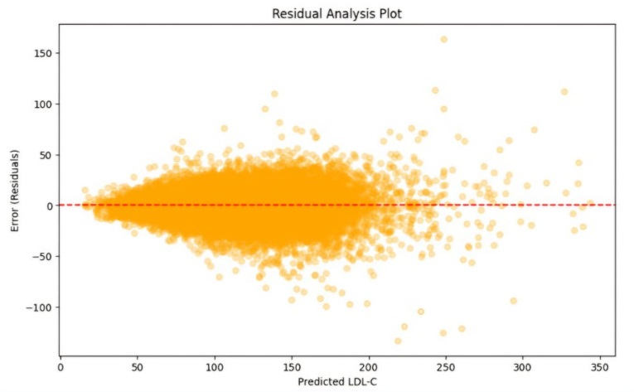
Figure 6. Residual plot for XGBoost model
The XGBoost model demonstrates its ability to forecast LDL-C levels through this residual plot. The x-axis represents the predicted LDL-C values generated by the model, while the y-axis shows the residuals (prediction errors), which were calculated as the difference between actual LDL-C measurements and their predicted values.
The residuals should display random distribution patterns which center on zero point while showing no distinct movement pattern. The distribution shows that the model predicts LDL-C values without systematic errors while maintaining equal accuracy for all prediction intervals. The absence of any visible trend or pattern in the plot indicates that the XGBoost model accurately captures all fundamental data relationships.

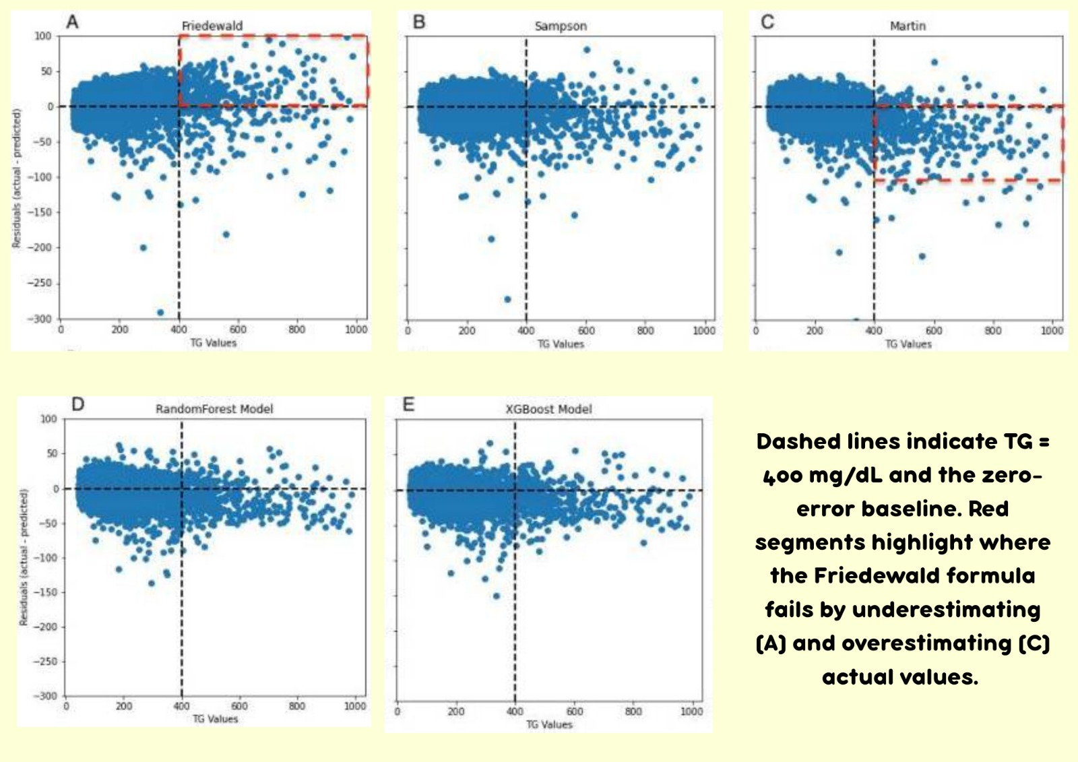

Figure 7. Distribution of LDL-C prediction errors across triglyceride concentration ranges using the XGBoost model.
The residual plots display prediction errors through their visualization of the difference between predicted values and actual LDL-C measurement. Residuals should show random distribution that maintains zero value but current classical formula methods demonstrate increasing variance based on rising triglyceride levels. The formulas which use fixed lipid ratio assumptions produce predictions that systematically underestimate or overestimate results at high TG concentrations. XGBoost residuals show equal distribution throughout all triglyceride levels without any patterns that create funnel shapes or curves, which proves the method maintains reliable performance during tough lipid testing situations.
The error distribution histograms present clear evidence that demonstrates these two distinct characteristics. Classical formulas produce wider, asymmetric distributions with heavier tails, which means that their distributions contain a greater chance of extreme values. XGBoost produces distributions that are both narrower and more symmetric, which centers around zero, while displaying decreased systematic bias and reduced extreme outlier presence. The patterns show that XGBoost delivers steady prediction ability through its entire dataset.
The combination of residual plots with error histograms establishes strong visual proof that XGBoost achieves superior numerical precision while delivering consistent performance throughout all clinical lipid testing scenarios. Its ability to provide accurate predictions throughout lipid screening processes makes it ideal for high-risk patient assessments, which demonstrates its advantages over traditional formula-based methods.
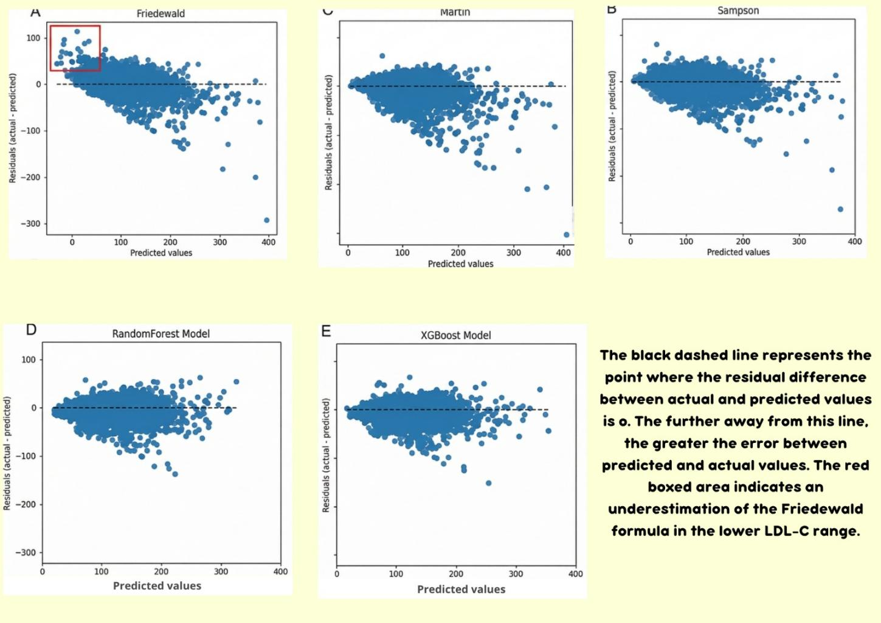

Figure 8. Scatter plot comparing residual and predicted values in secondary internal validation set.

The secondary internal validation set contains Figure 9 which displays scatter plots of residuals that show the difference between predicted and actual LDL‑C values against predicted LDL‑C values. The plots show that the horizontal dashed line at zero represents perfect prediction because it shows that predicted LDL‑C equals measured LDL‑C. The distance of points from this line shows the size of errors because points that stay close to zero produce better results. The Friedewald formula panel shows that systematic underestimation of LDL‑C occurs in the lower range because classical formulas produce results that differ from actual values.

XGBoost and Random Forest both demonstrate better prediction accuracy through their minimal residuals and tightly packed results at the zero line when compared to the Friedewald, Martin and Sampson formulas. The visual pattern shows that XGBoost predicts LDL-C values with high accuracy because it produces fewer significant errors throughout the entire prediction range. Classical formulas produce wider accuracy ranges which lead to more substantial errors especially when predicting extreme LDL-C levels because they lack consistency in their estimation process.
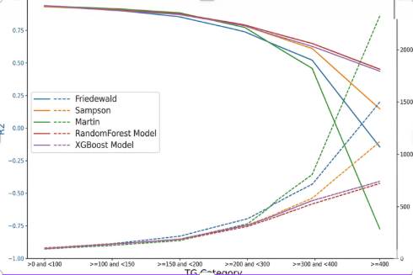
Figure 9. Performance comparison of different LDL-C estimation methods
The figure displays a comparison between the XGBoost model and traditional LDL-C estimation methods which include Friedewald, Martin, and Sampson. The figure shows that the XGBoost achieves better results than traditional methods because it shows higher coefficient of determination (R²) values which indicate stronger ability to explain the variability in actual LDL-C measurements and it shows lower mean squared error (MSE) and mean absolute error (MAE) which demonstrate smaller overall and average prediction errors. The comparison demonstrates that machine learning provides its most important advantage because XGBoost uses dynamic learning to understand complex nonlinear interactions between lipid parameters which enable it to deliver precise predictions for patients with unusual lipid profiles and high triglyceride levels. The figure shows that traditional formulas can achieve decent results during normal operating conditions but their accuracy decreases when tested with extreme triglyceride or LDL-C values while the XGBoost provides consistent performance throughout different testing conditions. Figure 10 demonstrates that machine learning improves LDL-C estimation accuracy because it shows potential to advance cardiovascular risk assessment and personalized treatment decision-making in clinical settings.
3.3 Discussion
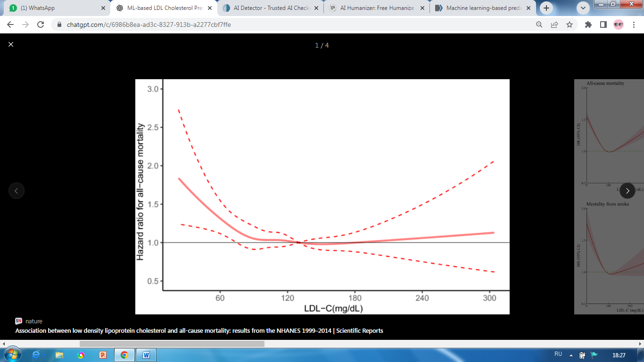
Figure 10. Restricted cubic spline analysis of the association between LDL-C levels and all-cause mortality.
The primary metric researchers used to assess cardiovascular disease (CVD) risk and total mortality rates established low-density lipoprotein cholesterol (LDL-C) as their main measurement tool. The meta-analyses and large studies demonstrate that elevated LDL-C levels lead to higher CVD mortality rates and various other health problems. The meta-analysis which examined more than 1.2 million adults found that people with LDL-C levels between 130–159 mg/dL experienced 1.26 times greater risk of dying from CVD than those with LDL-C levels between 70–129 mg/dL. Real-world data from more than two million coronary artery disease patients showed that extremely high (>130 mg/dL) LDL-C levels increase all-cause mortality, while different populations need separate optimal LDL-C level thresholds [4].
Population-based follow-up studies investigated how LDL-C levels connect to mortality rates. A study with more than 92,000 participants found that LDL-C levels create two types of associations which show U-shaped and J-shaped results for cardiovascular mortality rates, depending on individual risk factors and preventive methods. The restricted cubic spline analyses showed that both very low and very high LDL-C levels increase mortality rates, which the NHANES data confirmed. The study results show that LDL-C functions as both a modifiable risk factor and a main predictor of death risk.
Machine learning models, including Random Forest and XGBoost regressors, demonstrate better performance than traditional formulas which include Friedewald, Martin, and Sampson for predicting LDL-C levels. The models establish complex, nonlinear connections between lipid parameters which allow for patient-specific testing that includes high triglycerides and low LDL-C concentrations. The performance metrics demonstrate their capabilities: XGBoost achieves high R² values which show the model explains most LDL-C variance and the model displays low MAE and MSE values which indicate it produces only minor prediction inaccuracies. The models deliver exact and dependable predictions which help doctors evaluate cardiovascular risk and manage patient lipid levels in clinical settings.

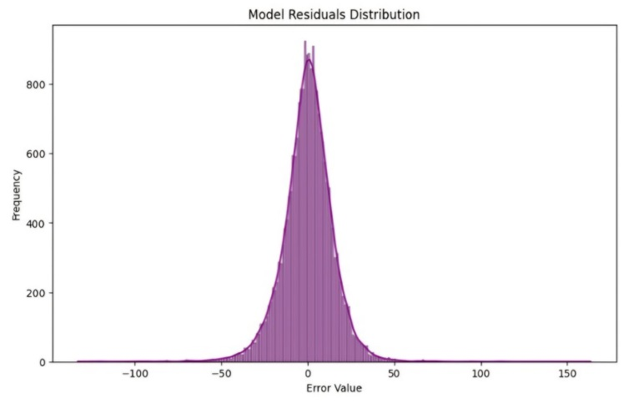
Figure 11. XGBoost model residuals distribution
The histogram shows how XGBoost model prediction errors are distributed across various time periods. The x-axis shows residual error values while the y-axis displays their corresponding frequencies. The observation peak occurs at zero error point which has more than 800 occurrences to demonstrate that most predictions match actual LDL-C values. The frequency starts to decrease when error size increases in both directions until it reaches almost zero at about ±50. The model produces minor residuals as its main output because it generates major prediction errors only during exceptional situations which enable the system to demonstrate its outstanding prediction accuracy and stable performance.
To confirm that XGBoost was the most suitable model for this task, additional machine learning algorithms were evaluated during preliminary experiments which included the Random Forest regression model that is widely known for its strong performance on structured datasets. The two models used identical training and testing splits to evaluate their performance on the same dataset. XGBoost required less hyperparameter tuning than Random Forest yet achieved better predictive accuracy across distinct lipid ranges. XGBoost models demonstrate superior performance against environmental noise and medical dataset outliers which frequently occur in clinical data. The results show that XGBoost provides an optimal combination of predictive accuracy, interpretability, and computational efficiency which enables effective LDL-C prediction.
The model achieves strong prediction capabilities but needs additional testing to assess its performance on fresh data from different sources. The upcoming studies will assess the LipidAI model through testing with external clinical databases and patient groups. The process of external validation serves as a vital component within machine learning research because models developed with one dataset tend to learn features which only exist in that particular dataset. The researchers need to test the model with independent populations because this method enables them to verify whether the algorithm delivers steady results throughout various demographic and clinical settings, which is essential for establishing trust and supporting its potential use in clinical practice.
Conclusion
In this work, we developed and evaluated two machine learning models, Random Forest and XGBoost, for predicting low-density lipoprotein cholesterol (LDL-C) using standard lipid profile parameters, including total cholesterol (TC), triglycerides (TG), HDL-C, and age. Both models demonstrated strong ability to capture the relationship between lipid features and LDL-C levels.
Through systematic training, cross-validation, and hyperparameter optimization, we compared the performance of both models using multiple evaluation metrics, including R², MSE, MAE, and Pearson correlation coefficient. The results showed that while both models achieved high predictive accuracy, XGBoost consistently outperformed Random Forest in terms of stability and overall performance.
Furthermore, the machine learning models were compared with traditional LDL-C estimation formulas such as Friedewald, Martin, and Sampson. The findings indicate that machine learning approaches provide more accurate and reliable predictions, especially under varying triglyceride levels, where traditional formulas tend to lose precision.
The results demonstrate that XGBoost is an effective and practical solution for LDL-C estimation in clinical settings. It can be particularly useful in scenarios where direct laboratory measurement is limited due to cost, time, or resource constraints. By improving the accuracy of LDL-C estimation, the proposed approach has the potential to enhance cardiovascular risk assessment and support better clinical decision-making.
Future work may focus on expanding the dataset with more diverse populations and integrating the model into real clinical systems to further improve its robustness and applicability.
References
[1] Ference BA, Ginsberg HN, Graham I, et al.
Low-density lipoproteins cause atherosclerotic cardiovascular disease. European Heart Journal. 2017;38(32):2459–2472.
[2] Rifai N, Warnick GR, McNamara JR, et al.
Measurement of low-density lipoprotein cholesterol in serum: a status report. Clinical Chemistry. 1992;38(1):150–160.
[3] Friedewald WT, Levy RI, Fredrickson DS.
Estimation of the concentration of low-density lipoprotein cholesterol in plasma, without use of the preparative ultracentrifuge. Clinical Chemistry. 1972;18(6):499–502.
[4] Zhang Y, Vittinghoff E, Pletcher MJ, Allen NB, Al Rifai M, Rana JS. Association between low-density lipoprotein cholesterol levels and mortality risk: a population-based study. Scientific Reports. 2021;11:1738. doi:10.1038/s41598-021-01738-w.
[5] Liu J, Li Y, Zhao D, Wang W, Sun J, Qin X. Association of LDL-C levels with cardiovascular and all-cause mortality: a large cohort analysis. Cardiovascular Innovations and Applications. 2023;8(3):Article cm9.0000000000003199. doi:10.15212/CVIA.2023.3199.
Mentor’s review
Modern biomedical research and clinical practice urgently require solutions to predict low-density lipoprotein cholesterol (LDL-C) through machine learning technology. Cardiovascular diseases continue to be the main cause of death throughout the world because physicians need to know LDL-C levels for risk assessment and treatment selection. The formula-based methods which doctors use for LDL cholesterol measurement provide simple solutions but they fail to deliver accurate results when patients have high triglyceride levels or low LDL cholesterol levels. XGBoost serves as a solution to LDL-C prediction problems because it delivers accurate predictions based on data while maintaining strong performance throughout its application.
The authors have demonstrated a clear understanding of the subject matter and independently developed a machine learning workflow for LDL-C prediction. The work includes literature review, selection and justification of the XGBoost model, data preprocessing, model training and validation, and comparative analysis with traditional estimation formulas. The authors prepared Figures 1–10, performed residual and performance analysis, and provided a structured discussion of results. These contributions indicate a high degree of personal involvement and independent work throughout the research.
The research study demonstrates proper research methods but it has multiple limitations which must be addressed. The research work uses one dataset as its primary data source which limits its ability to establish results that apply to various population groups. The researchers need to provide more specific information about their hyperparameter optimization process because they have only mentioned it in general terms
The author needs to demonstrate model testing through an external dataset which will produce results that are more trustworthy and can be applied to more situations. The methodological section would benefit from additional details about hyperparameter tuning and feature importance analysis methods. The research needs to demonstrate how the model functions as a practical tool for clinical settings while being incorporated into standard procedures for lipid assessment. The research establishes significant value through its work which creates a basis for future studies that will use machine learning to forecast lipid levels.
In conclusion, the work is relevant, scientifically sound, and demonstrates the author’s personal contribution to the field. With minor improvements in methodological detail and validation, the research is suitable for submission or presentation in an academic context.

